



**Module Code & Title**

CS6P05 Final Year Project MAD

Food Share - Android App

**Artifact – Maintenance­ and release**

**Student Details**

Name: Sita Ram Thing

London Met Id: 22015892

College Id: NP01MA4S220003

Islington College, Kathmandu

24 April 2024

Contents

1. Introduction 4

1.1 Release APK 4

1.2 UI Maintenance 13

**List of Figures**

Figure 1: Introduction to the release apk 4

Figure 2: Converter stage of development to the user. 5

Figure 3: Set up details for release. 6

Figure 4: Generate the Bundle or APK.’ 7

Figure 5: Release success message. 7

Figure 6: Generate the APK 8

Figure 7: Select the APK 9

Figure 8: Generate the bundle or an APK 10

Figure 9: Go to release the APK 11

Figure 10: Loading or building the apk 11

Figure 11: Generate APK 12

Figure 12: APK file share for free within 24 hours 12

Figure 13: APK uploads successfully. 12

Figure 14: UI Maintenance to show the modification in Badge 13

Figure 15: Display the confirmation dialog box before deleting 14

Figure 16: Navigate to the inner screen the hide the button navigation bar 15

Figure 17: Any action the user danger action shows the confirmation dialogue 18

# Introduction

## 1.1 Release APK

Figure 1: Introduction about the release apk

Figure 2: Converter stage of development to the user.

Figure 3: Set up details for release.

Figure 4: Generate the Bundle or APK.’

Figure 5: Release success message.

Figure 6: Generate the APK

Figure 7: Select the APK

Figure : Generate the bundle or an APK

Figure 9: Go to release the APK

Figure 10: Loading or building the apk

Figure : Generate APK

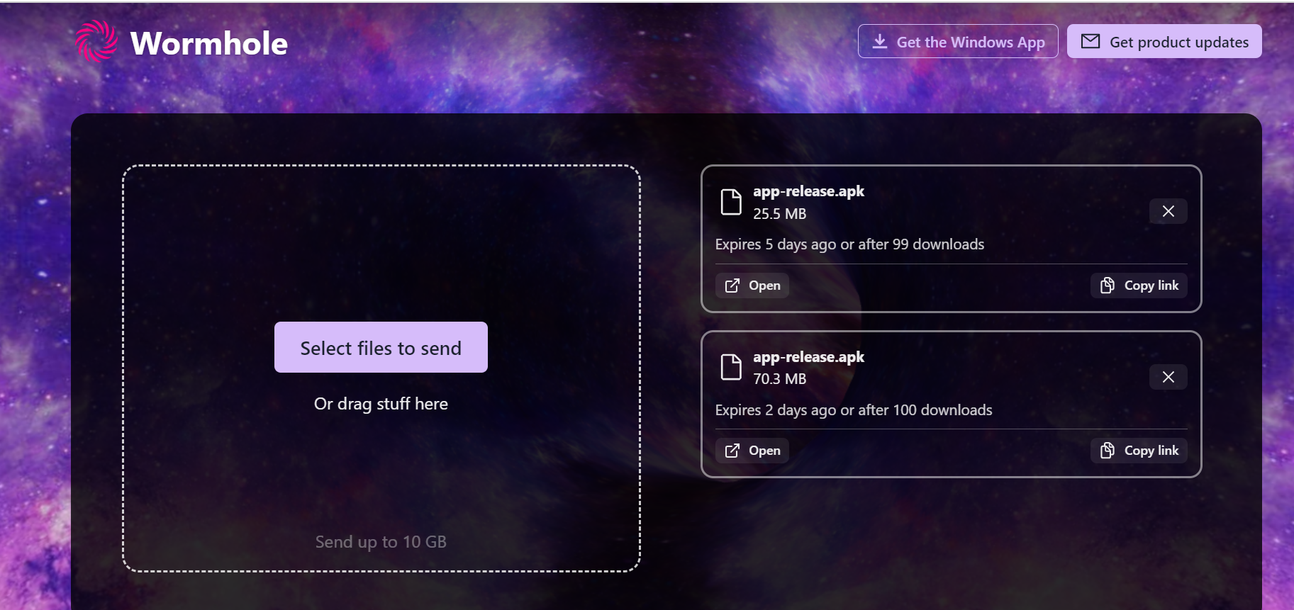

Figure 12: APK file share for free within 24 hours

Figure 13: APK uploads successfully.

## 1.2 UI Maintenance

Figure : UI Maintenance to show the modification in the Badge

Figure 15: Display the confirmation dialog box before delete

Figure 16: Navigate to the inner screen the hide the button navigation bar

Figure : Any action the user danger action shows the confirmation dialogue